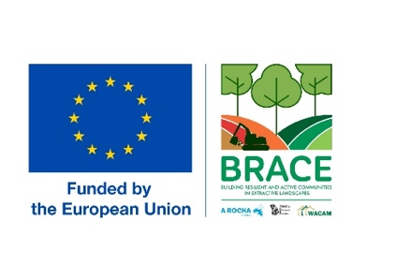

**Project logframe and activities**

Kindly use this template for your logframe as part of your application for the above funding.

*The logframe captures in a structured way the hierarchy of results of the action at impact, outcome and output levels. The impact is the long-term expected effect of the action. The outcomes are the expected effects of the action. The links between each level are as important as the results themselves, reflecting the intervention logic (theory of change) and the roles of providers and other stakeholders.*

*The logframe can be used to help in reporting your results during implementation and will be updated as you progress with your activities and outputs.*

Please number your activities consistent with your output numbering. Also ensure the numbering you use here is the same as the numbering in your narrative proposal.

We have provided guidance in a separate document in case you need it.

You can add or remove lines as necessary.

This is also in an Excel format if you prefer to use Excel.

* Project title:
* Applicant organisation/s:

|  |  |  |  |  |  |  |
| --- | --- | --- | --- | --- | --- | --- |
| Impact statement | Expect Outcomes | Outputs | Baseline | Target value | Means of verification | Activities |
|  | EO1 | O1.1: |  |  |  | A1.1: |
| O1.2: |  |  |  | A1.2: |
|  |  |  |  |  |
|  |  |  |  |  |
| EO2 |  |  |  |  |  |
|  |  |  |  |  |
|  |  |  |  |  |
|  |  |  |  |  |
| EO3 |  |  |  |  |  |
|  |  |  |  |  |
|  |  |  |  |  |
|  |  |  |  |  |